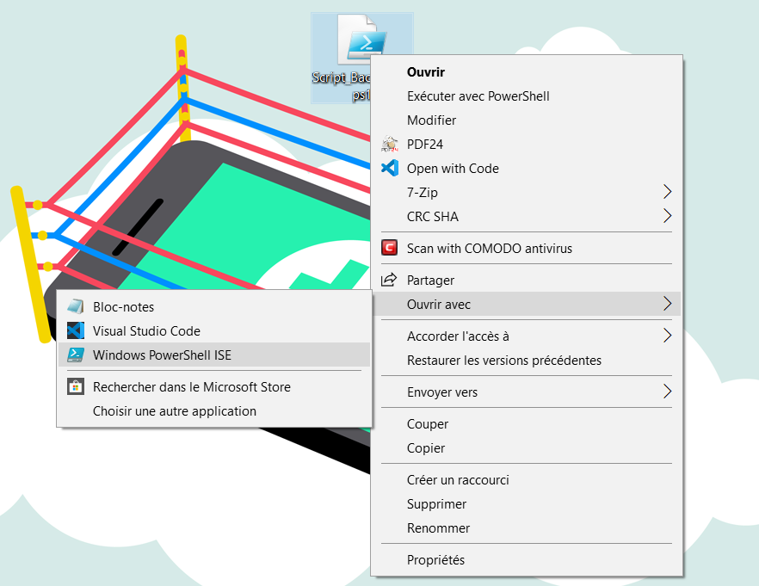

First, open the powershell script “Script_BackupVM.ps1” in Powershell ISE

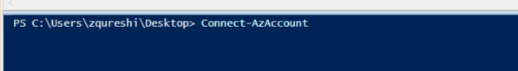

Once opened, you have to log in into Azure through the command line Connect-AzAccount

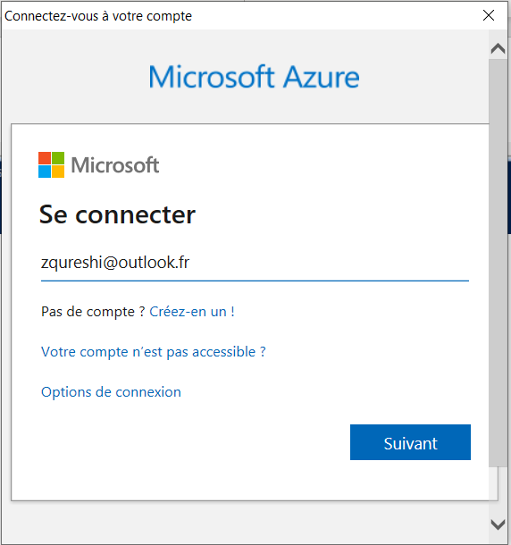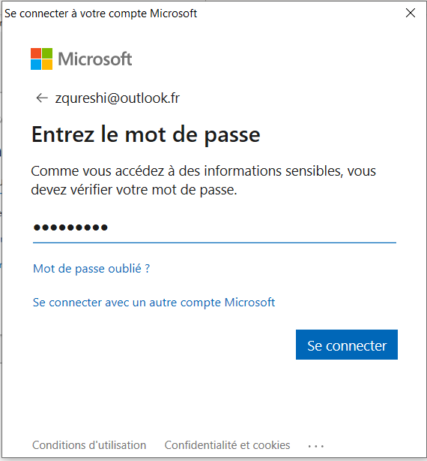

Enter your Azure Credentials through the popup window

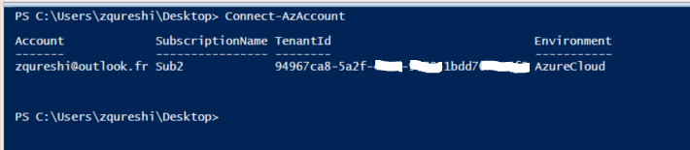

Once connected, you will see all subscriptions attached to your account

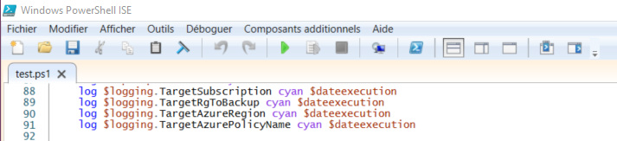

Click on the Play button on the middle-top

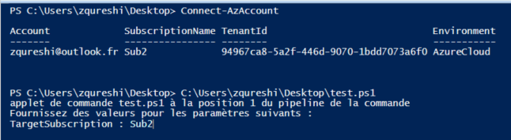

Write the name of the subscription which hosting the VMs to backup and press enter

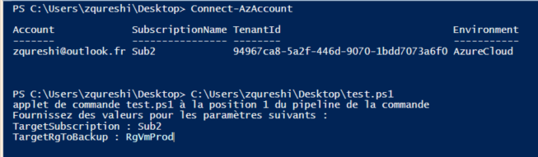

Write the name of the resource group which hosting the VMs to backup and press enter

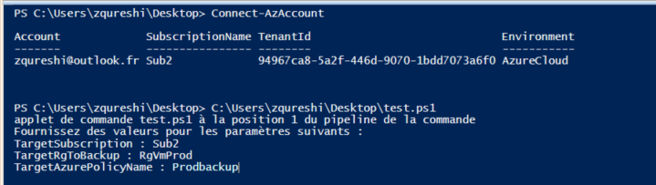

Define a name for the Policy to apply and press enter

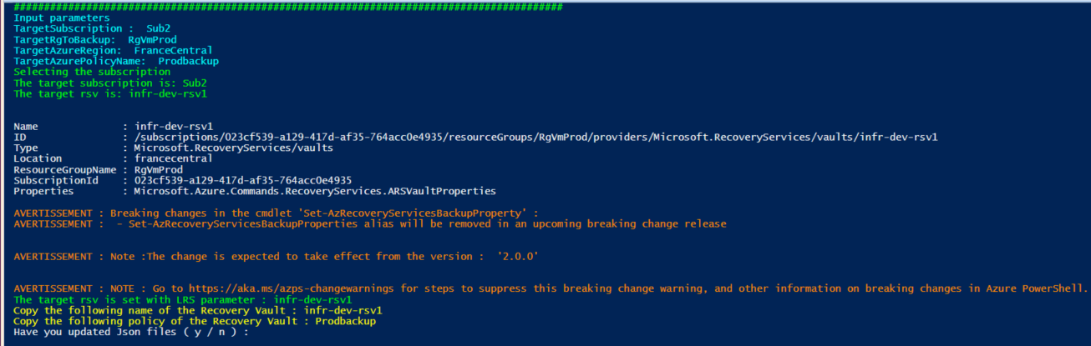

Copy the Recovery Vault name in yellow and the Policy name in a note pad

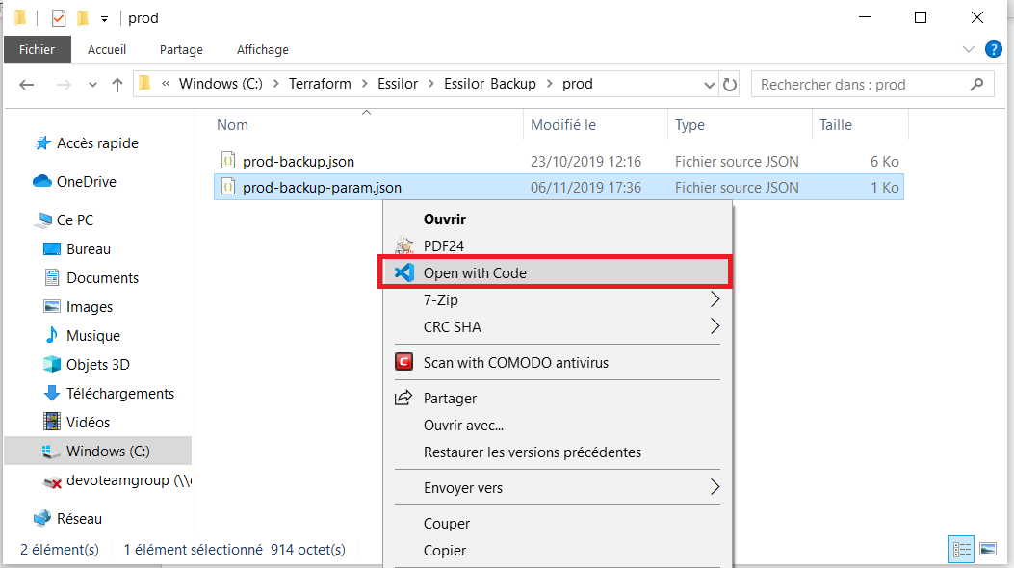

Open the Json Parameter files, to identify it you will see the word param into the name of the file.

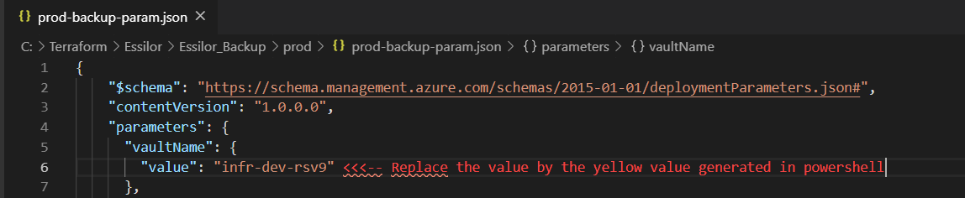

Replace the line 6 by the name of the Recovery Service Vault



Replace the line 9 by the policy Name

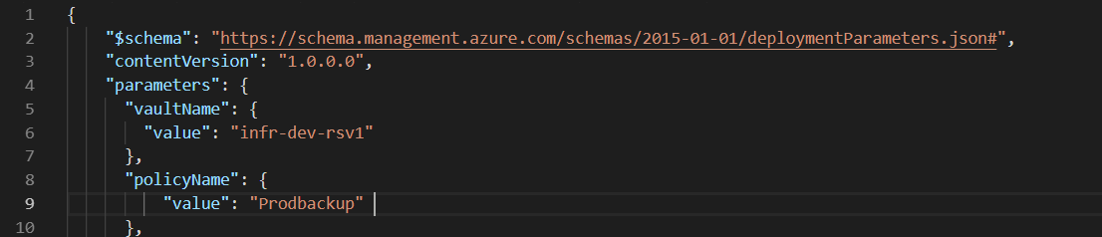

Then save the parameters file

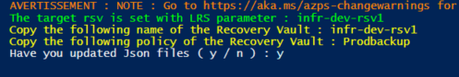

Type “y” and press enter

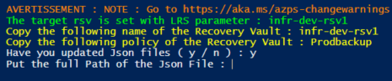

Located the Json file containing backup policy configuration

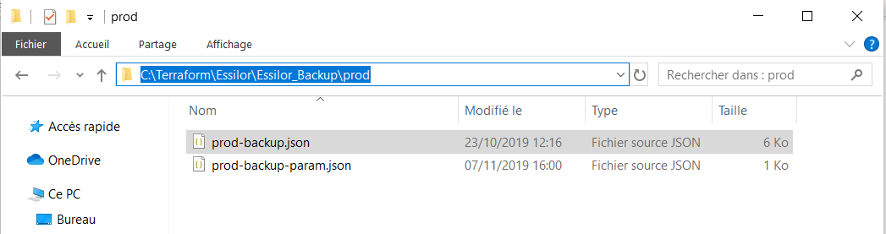

Copy the path

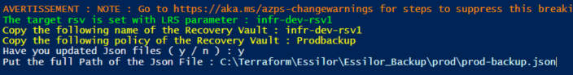

Paste the full path including the json

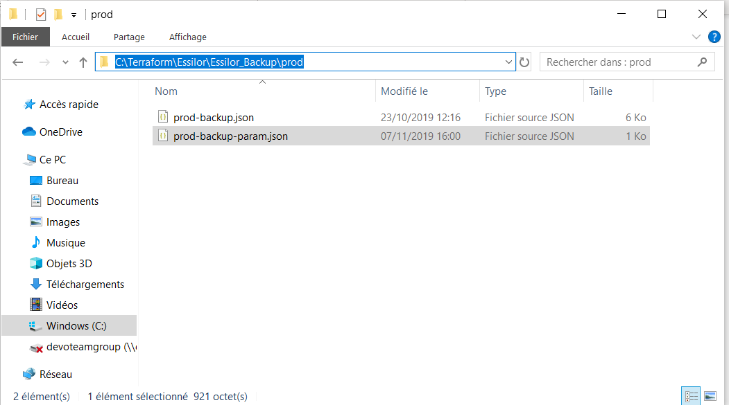

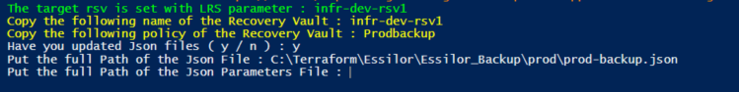

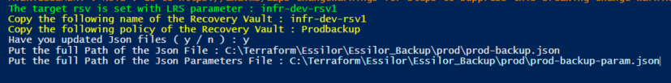

Do the same thing with the Json parameters file and press enter

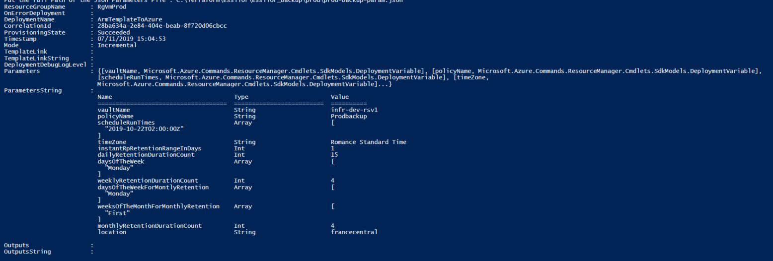

The backup policy is created and applied to the Recovery Services Vault

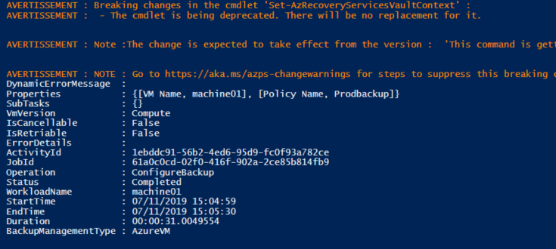

When you see that block, it means the policy is applied on the VM